Infosys Springboard Virtual Internship 6.0 Completion Report

# Team Details <Do not mention any personally identifiable information like email ID, institute details, mobile phone number etc.>

Batch Number: **NeuroFleetX AI Powered Urban Fleet and Traffic Intelligence**

**Start date :** 05-11-2025

**Names:**

1.Narmadha L

2.Ganesh S

3.Nitin Kamalesh

4.Pamala Dinesh Kumar

Internship Duration: 8 Weeks

# 1. Project Title

NeuroFleetX AI Powered Urban Fleet and Traffic Intelligence

**2. Project Objective**

NeuroFleetX is an AI-assisted fleet and traffic management system designed to help administrators, managers, and drivers monitor and manage urban traffic more effectively. The system analyzes vehicle movement and traffic data to identify congestion levels, risk zones, and unsafe areas on the road. Using interactive dashboards, maps, and visual charts, NeuroFleetX presents complex traffic information in a clear and easy-to-understand manner. It supports features such as real-time vehicle tracking, alert generation, traffic risk analysis, and route suggestions to improve safety and efficiency. The platform uses role-based access to ensure that each user—Admin, Manager, or Driver—receives relevant information and controls. While the current implementation uses basic AI-assisted logic, the system is designed to support future integration of advanced machine learning models for automatic traffic prediction and intelligent decision-making. Overall, NeuroFleetX aims to improve traffic awareness, reduce manual monitoring, and provide a strong foundation for smarter urban transportation systems.

# 3. Project description in detail

NeuroFleetX is a smart, AI-assisted fleet and traffic management system developed to address the growing challenges of urban traffic and vehicle monitoring. As cities become more crowded and the number of vehicles continues to increase, managing traffic efficiently and ensuring road safety has become difficult using traditional systems. NeuroFleetX aims to provide a centralized digital platform to monitor vehicles, traffic conditions, and risk zones in an organized and visual manner.

The system is designed as a **full-stack web application**, where the frontend provides interactive dashboards and maps, and the backend handles data processing, storage, and security. Users interact with the system based on their roles—Admin, Manager, or Driver—each having controlled access to specific features.

The **Admin module** allows complete control over the system. Admins can manage users, drivers, and vehicles, monitor overall traffic conditions, view risk zones, handle alerts, and analyze traffic data using dashboards and charts. The admin dashboard acts as a city-level overview, showing vehicle status, congestion levels, and risk areas at a glance.

The **Manager module** focuses on operational traffic monitoring. Managers can update traffic data for different locations, monitor congestion and risk zones, track fleet status, and respond to alerts. This role helps ensure smooth day-to-day traffic and fleet operations.

The **Driver module** is designed for end users who are actively on the road. Drivers can create and view trips, follow suggested routes, share their location through GPS check-ins, view vehicle status, and receive traffic or safety alerts. This helps drivers avoid congested routes and travel more safely.

NeuroFleetX also includes **AI-assisted features** such as traffic analytics, risk zone identification, route suggestions, and alert generation. In the current phase, these features use basic AI logic and rule-based analysis to classify congestion levels and risk areas. The frontend visually represents this data using charts, color indicators, and maps to make complex traffic information easy to understand.

Although the current implementation uses manually entered or sample data, the system is designed to support future integration of advanced AI and machine learning models. In future versions, traffic data can be automatically collected and analyzed in real time to predict congestion, detect accidents, and suggest optimal routes without manual intervention.

Overall, NeuroFleetX provides a strong foundation for building an intelligent traffic and fleet management solution that improves traffic awareness, enhances safety, reduces manual monitoring, and supports smarter decision-making in urban transportation systems.

**4. Timeline Overview**

|  |  |  |
| --- | --- | --- |
| Week | Activities Planned | Activities Completed |
| Week 1 | Requirement gathering, problem analysis, and project planning | Requirements finalized, project idea approved, team roles assigned |
| Week 2 | Project scope definition and technology selection | Scope documented, tech stack finalized (React, Spring Boot, MySQL, JWT) |
| Week 3 | Database design and backend setup | Database schema created and tested with sample datasets |
| Week 4 | Authentication and role-based access implementation | Login & registration pages completed, JWT authentication implemented |
| Week 5 | |  | | --- | |  |  |  | | --- | | Admin module development | | Admin dashboard, user management, driver management, and vehicle management completed. |
| Week 6 | Manager and Driver module UI development | Manager dashboard, traffic management UI, driver dashboard, trip management UI completed |
| Week 7 | Alerts module and frontend integration | Alerts page implemented, create/resolve alerts, real-time refresh added |
| Week 8 | |  | | --- | |  | | AI Analytics frontend and system integration | | | AI Analytics UI completed, charts and risk visualization added, documentation finalized |

# 5a. Key Milestones

|  |  |  |
| --- | --- | --- |
| Milestone | Description | Date Achieved |
| Project Kickoff | Project kickoff defined objectives, scope, and roles. | 10 – Nov - 2025 |
| Prototype/First Draft | Developed the prototype for NeuroFleetX AI Powered Urban Fleet and Traffic Intelligence | 24- Nov - 2025 |
| Mid-Term Review | Completed mid-term review to assess progress and refine project approach. | 02- Dec - 2025 |
| Final Submission | Submitted the completed Budgetwise project with full functionality and documentation. | 17- Dec - 2025 |
| Presentation | Prepared and delivered the project presentation showcasing features and outcomes. | 3- jan - 2025 |

# 5b. Project execution details

* Requirement Analysis  
  Collected project requirements, understood traffic management problems, defined system scope, and finalized objectives.
* Technology Selection  
  Selected React for frontend, Spring Boot for backend, MySQL for database, and JWT for authentication. OpenStreetMap was chosen for map visualization.
* System Design  
  Designed database entities, API flow, role-based access structure, and basic UI layouts for Admin, Manager, and Driver dashboards.
* Authentication & Role Setup  
  Implemented login and registration pages with JWT-based security and role-based access control.
* Core Module Development  
  Developed Admin Dashboard, Vehicle Management, User Management, and Driver Management modules.
* Traffic & Fleet Features  
  Implemented traffic data handling, fleet status monitoring, and basic trip-related features.
* Alerts Module Implementation  
  Developed alert creation, viewing, severity classification, and resolve functionality with real-time refresh.
* AI Analytics (Frontend)  
  Designed AI Analytics dashboard using charts and color indicators to display traffic congestion and risk zones.
* AI Tools Integration (Basic Level)  
  Implemented route explorer and traffic analysis support features using basic AI-assisted logic.
* Testing & Integration  
  Tested frontend and backend integration, verified API responses, fixed UI and logic issues.
* Documentation & Presentation  
  Prepared project documentation, PPT, code explanation, and final project presentation.

# 6. Snapshots / Screenshots

**Step 1 : Go to Github and clone the Repository in your system then open in VS Code to do the execution , here is the github repo link :** https://github.com/NarmadhaLoganathan/NeuroFleetX-TeamB

**Step 2 : Folders,Terminal**

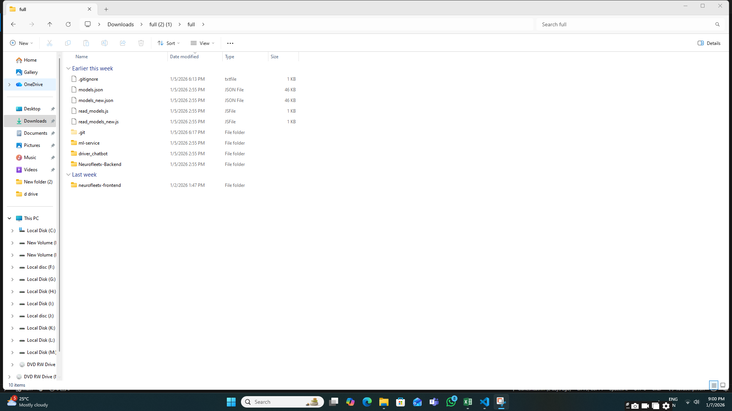

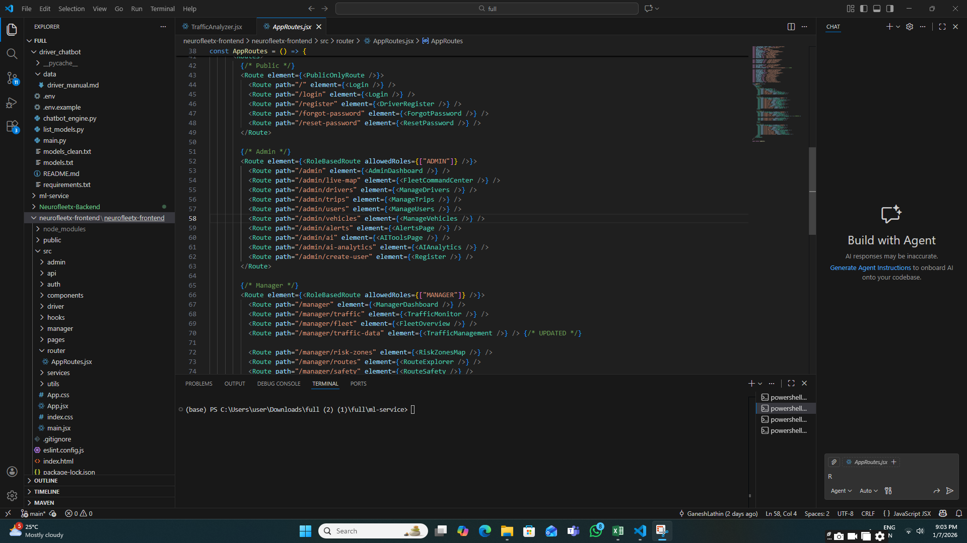

**Step 3 : Login / Signup Navigation**

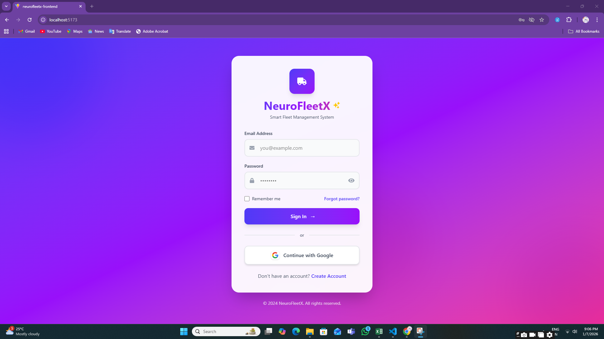 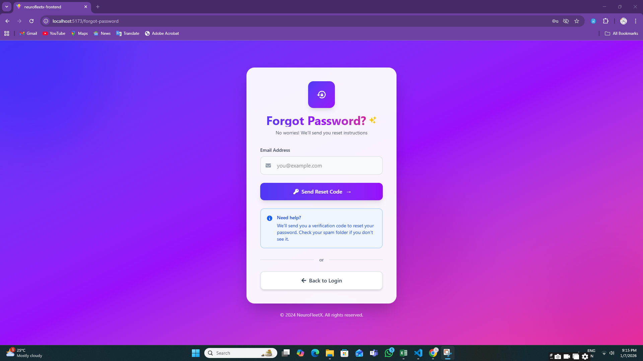

**Step 4: Registration Page**

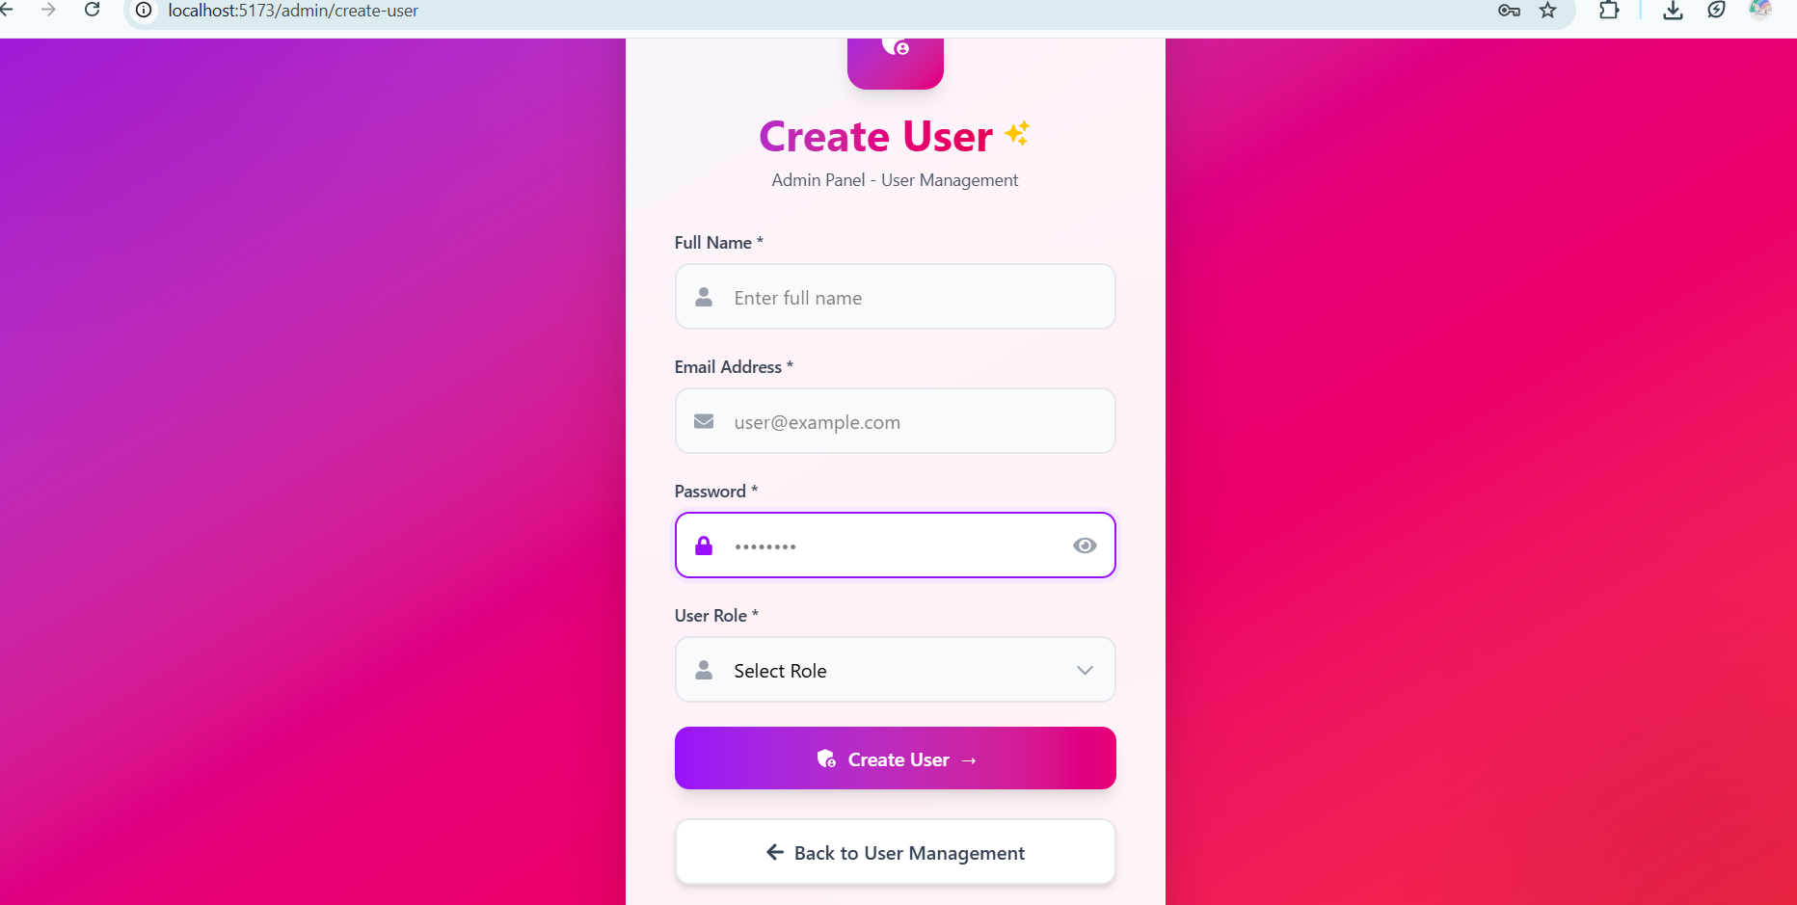

**Step 5: Role-Based Redirection**

After successful login, users are automatically redirected to their respective dashboards:

* **Admin Dashboard**

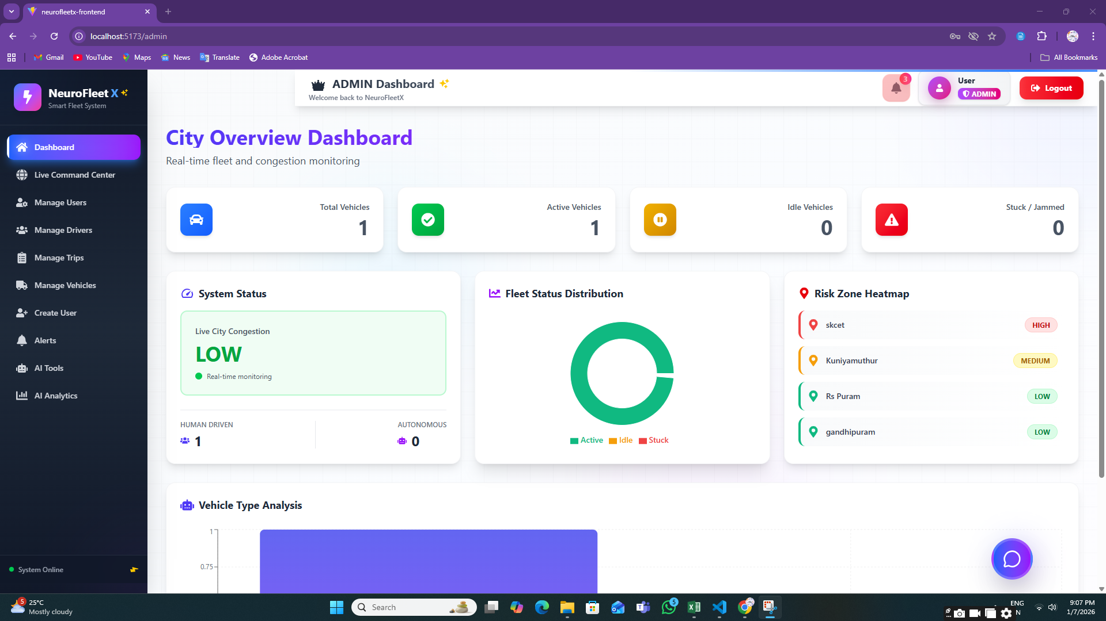

* **Manager Dashboard**

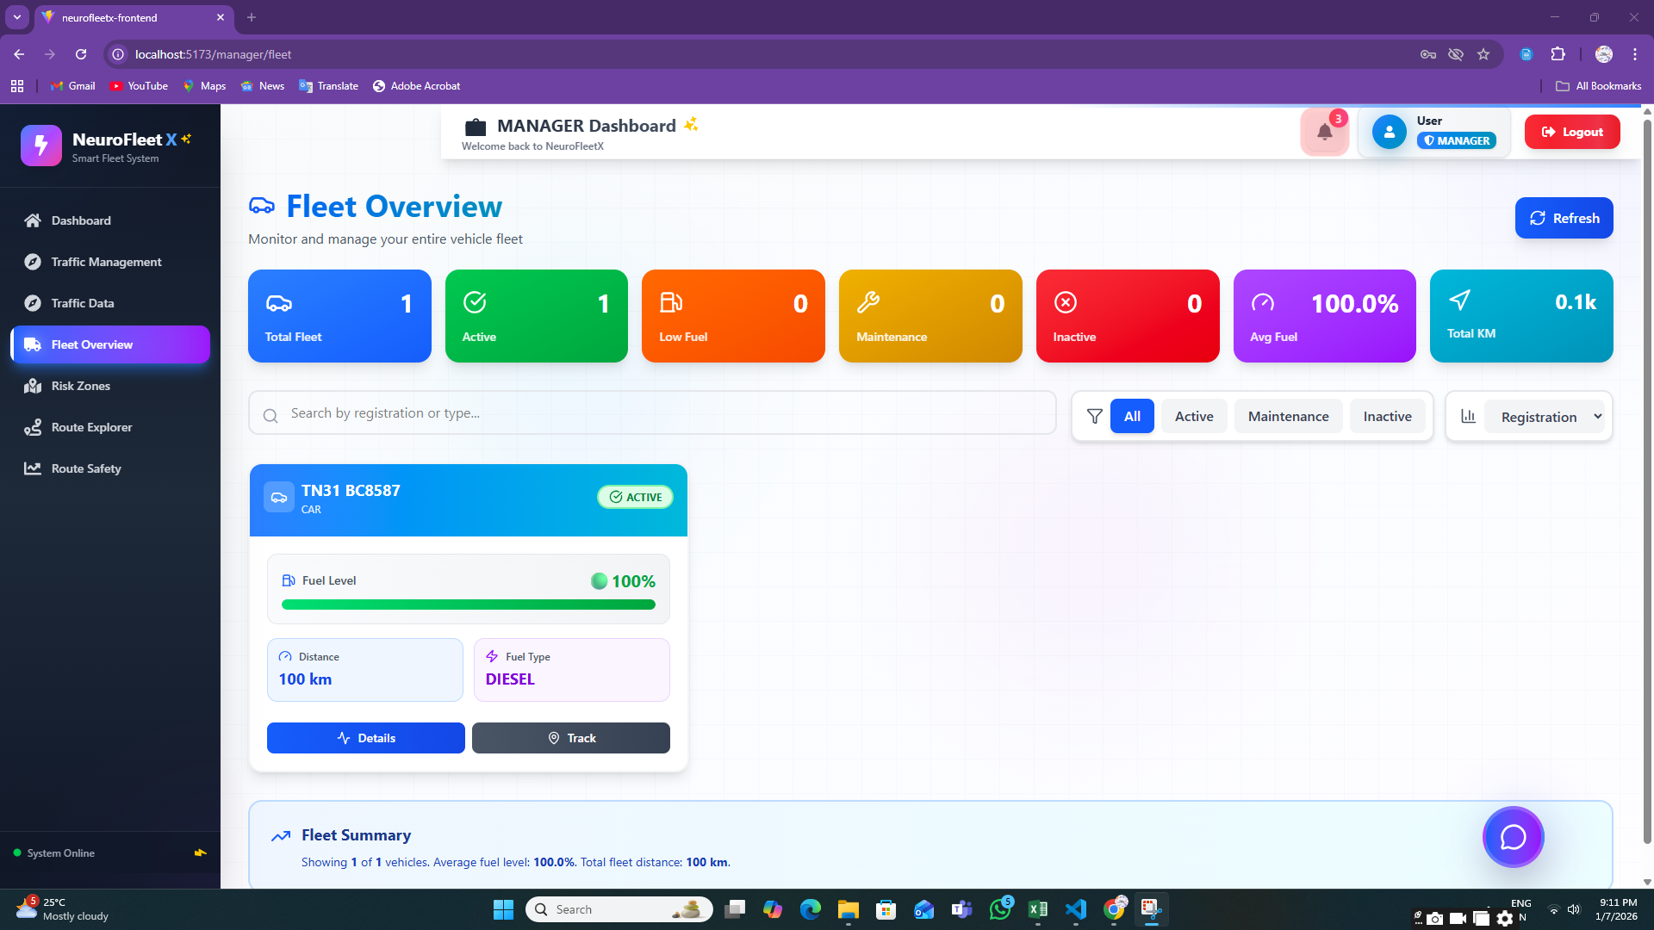

* **Driver Dashboard**

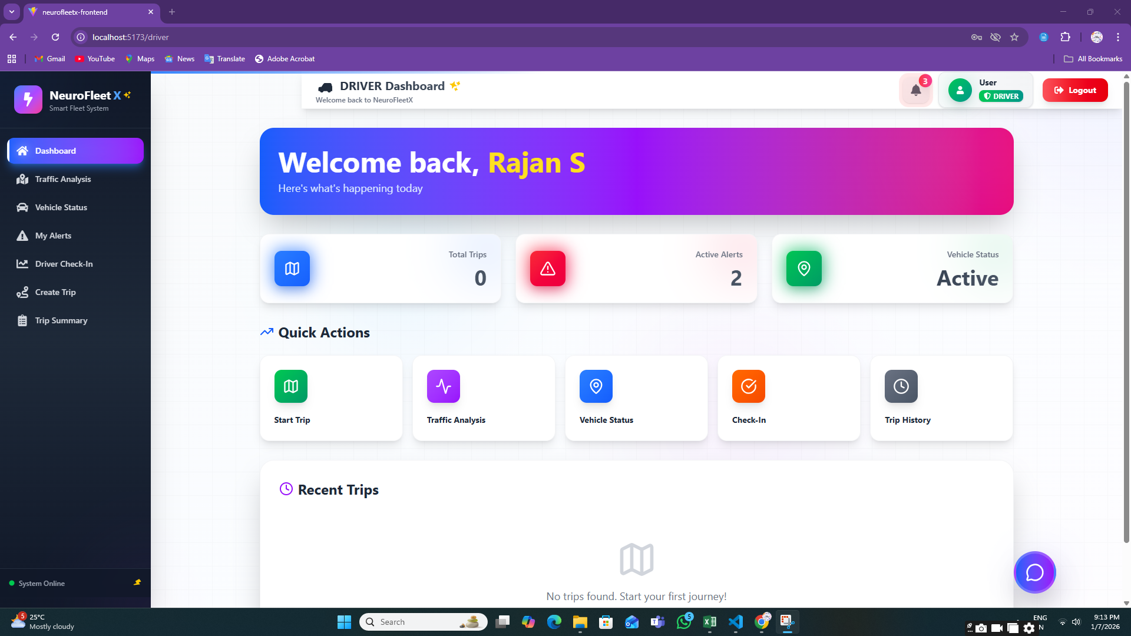

This confirms role-based access control.

**Step 6: ADMIN MODULE**

**6.1:** **Vehicle Management Page**

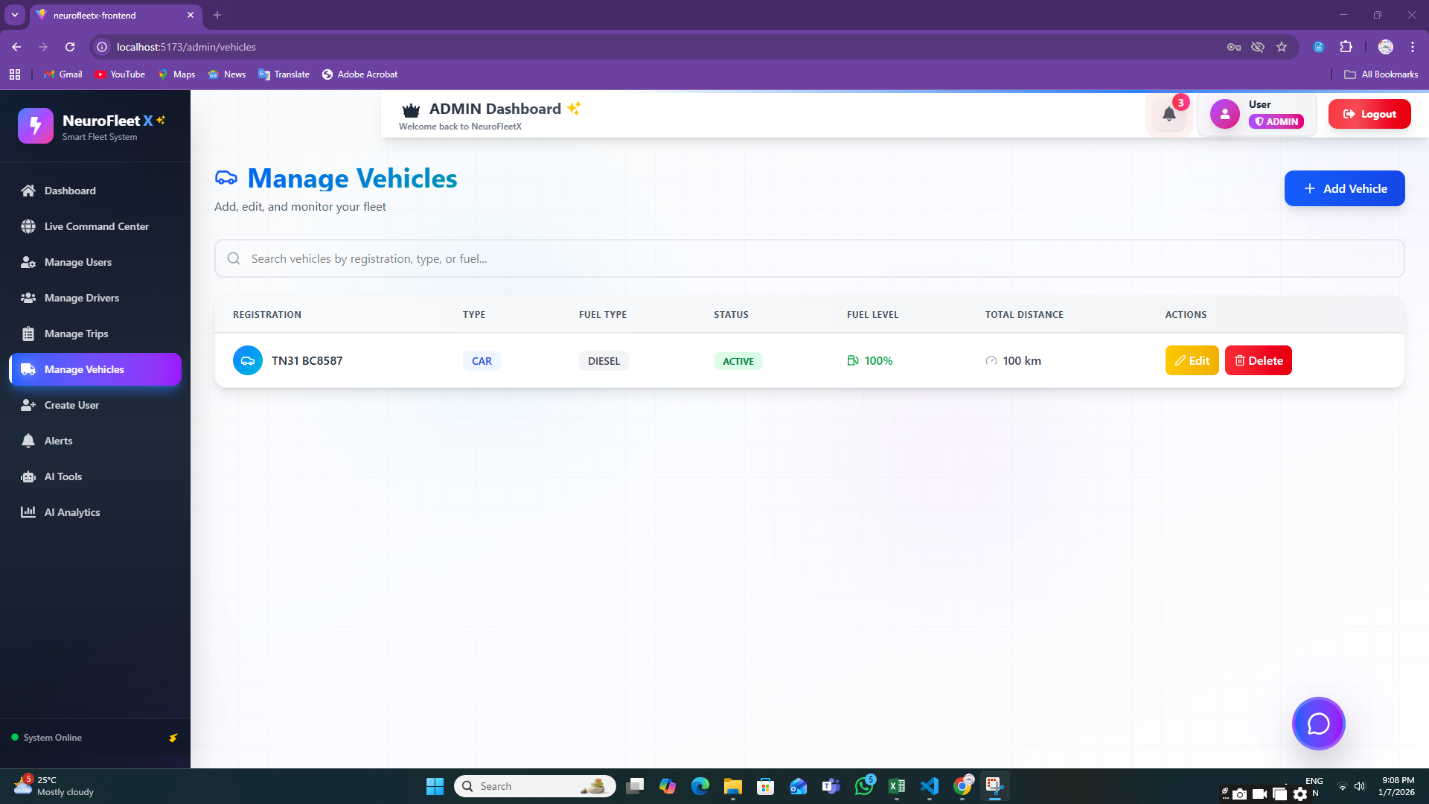

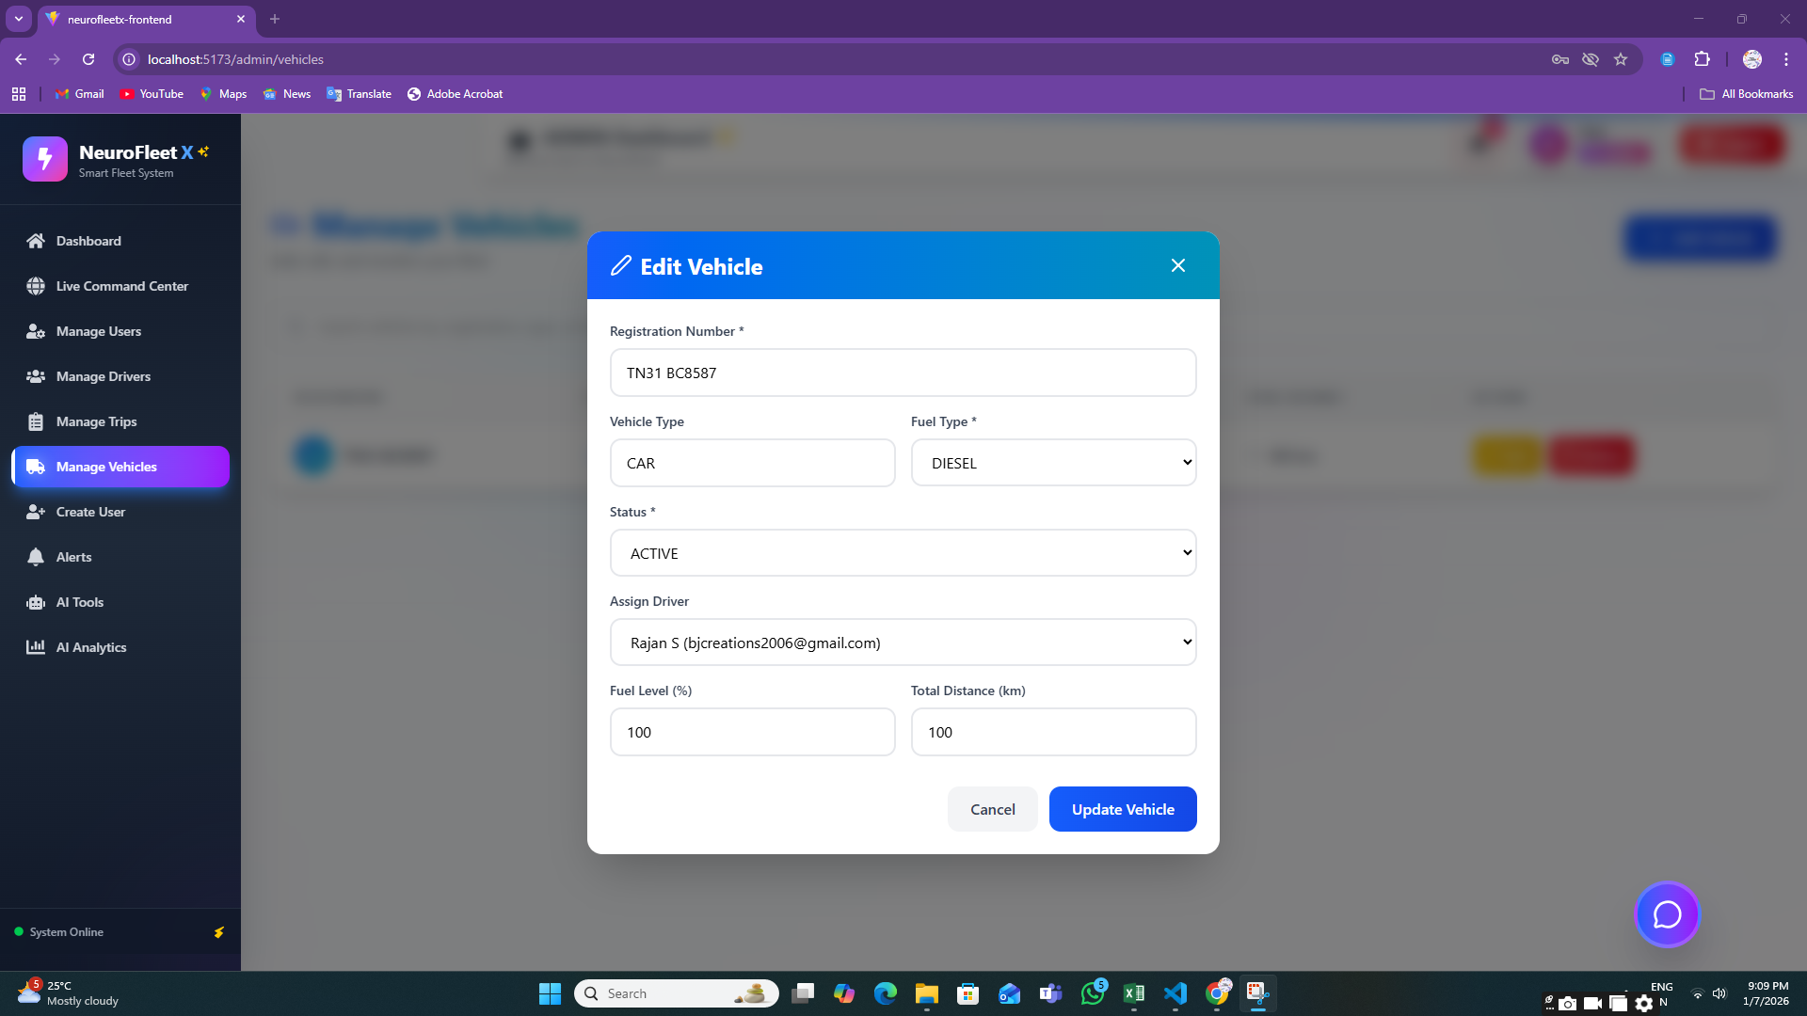

**6.2:** **User Management Page**

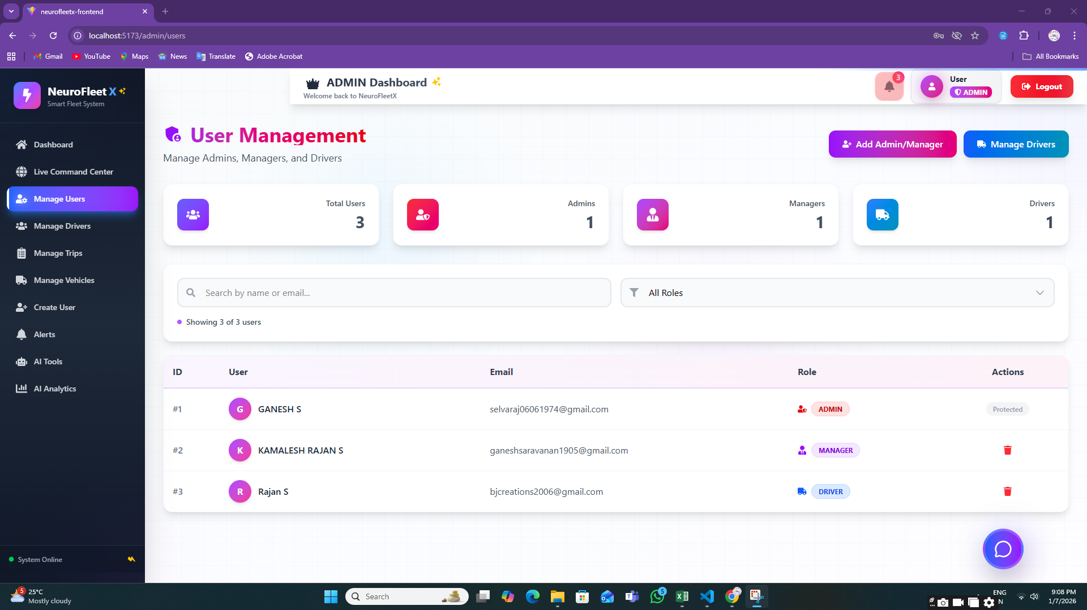

**6.3:** **Driver Management Page**

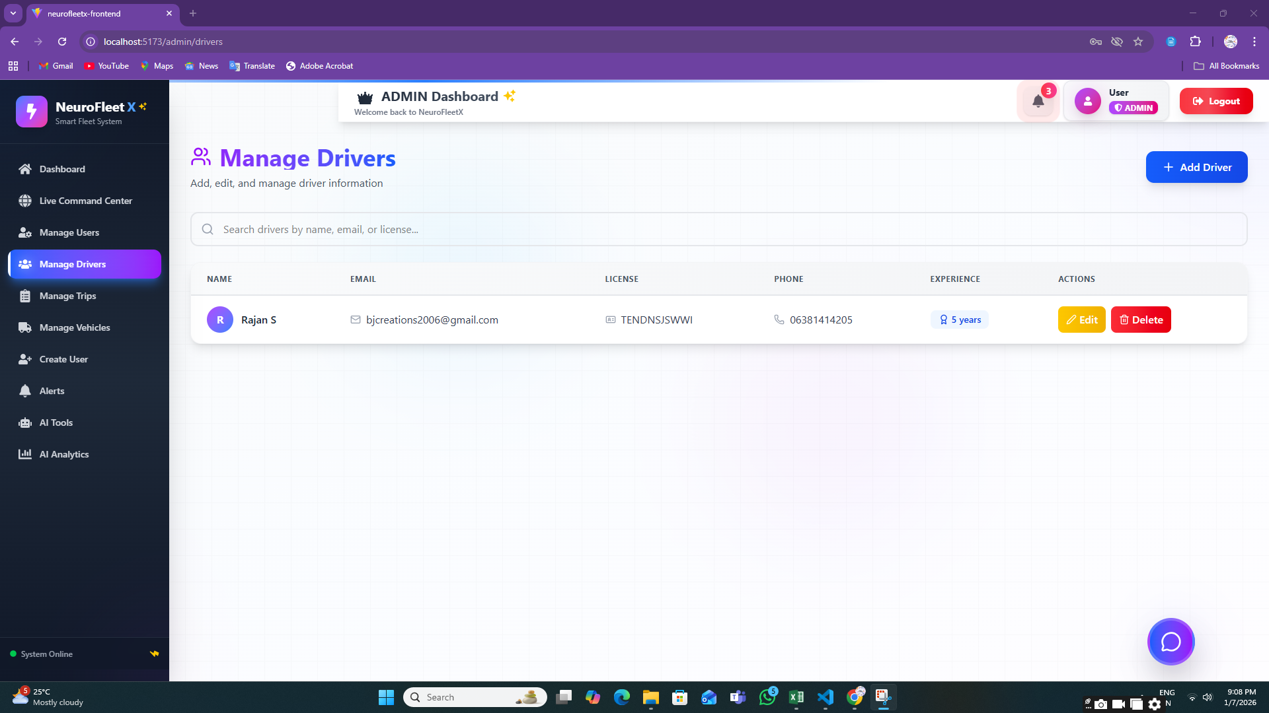

**6.4:** **Alerts Page (Admin View)**

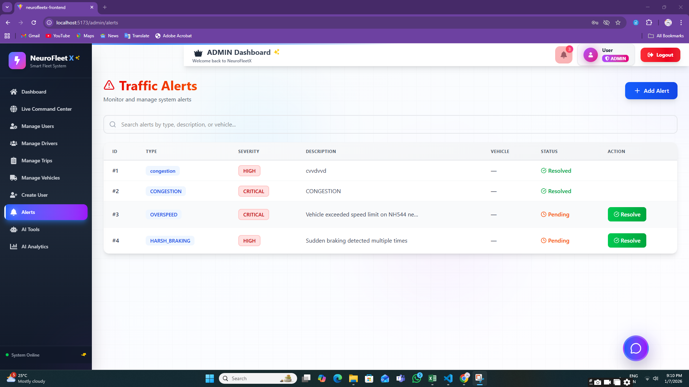

**6.5:** **AI Analytics Page**

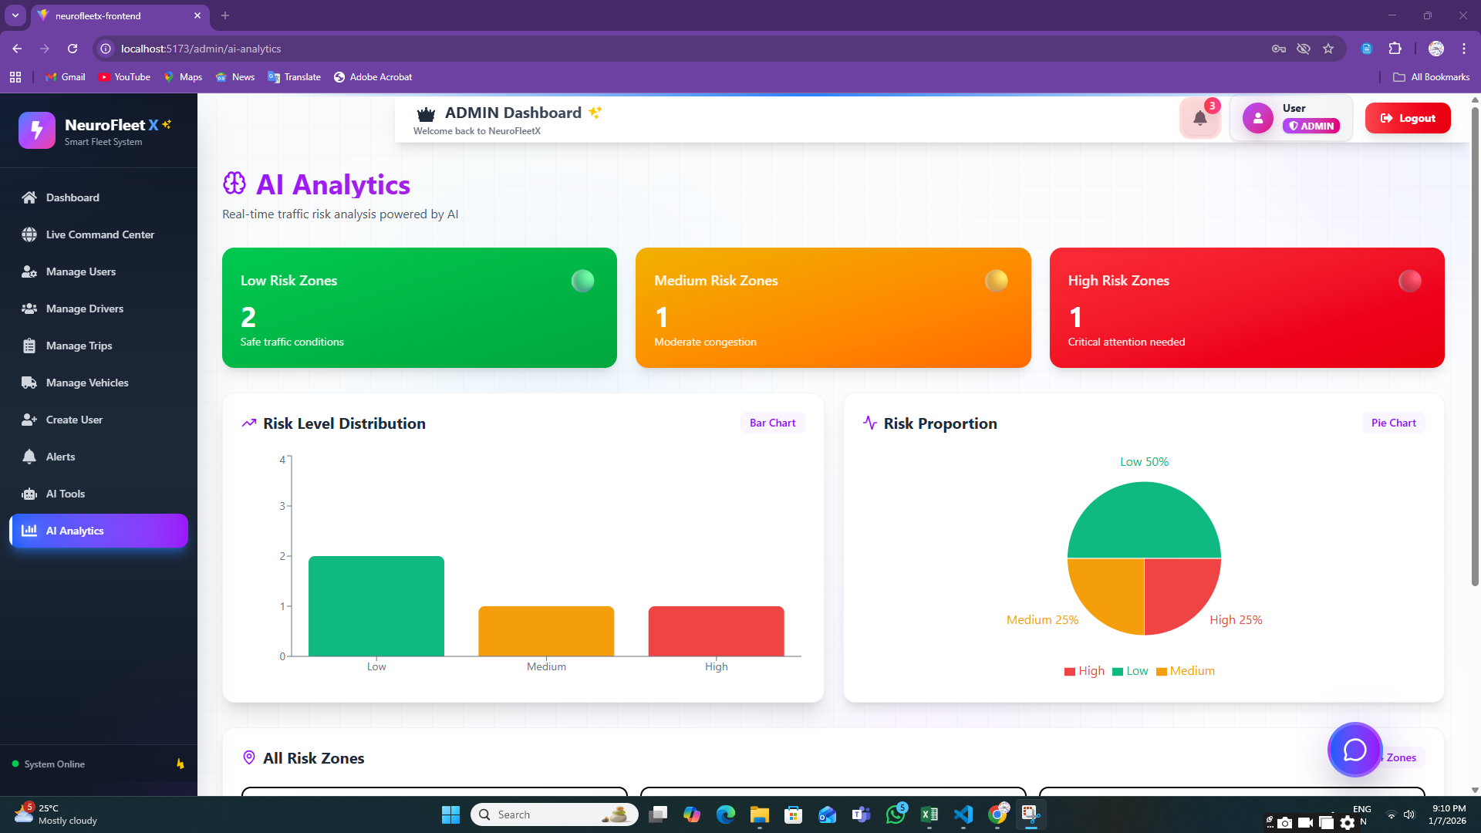

**6.6:AI Tools**

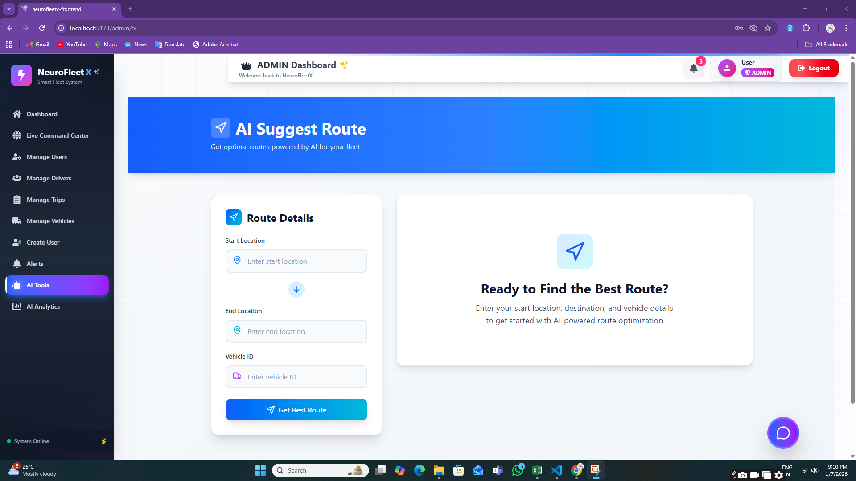

**6.7:Manage Trips**

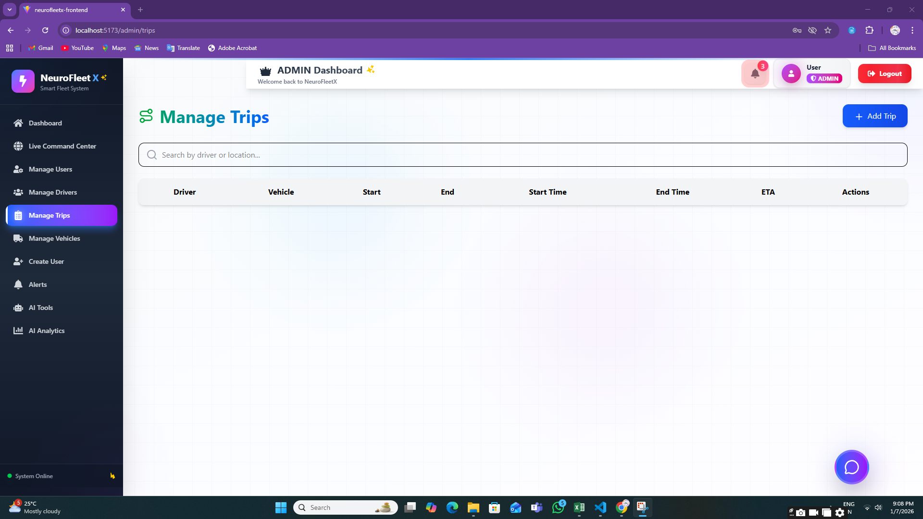

**Step 7:** **MANAGER MODULE**

**7.1:Traffic Management Page**

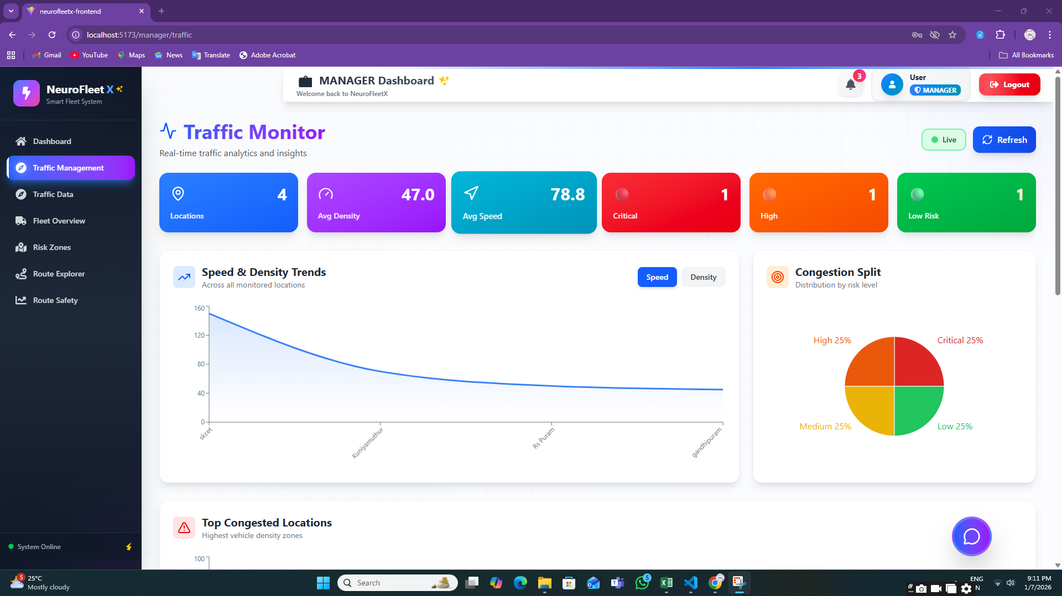

**7.2:** **Risk Zone Map**

**7.3:Traffic Data**

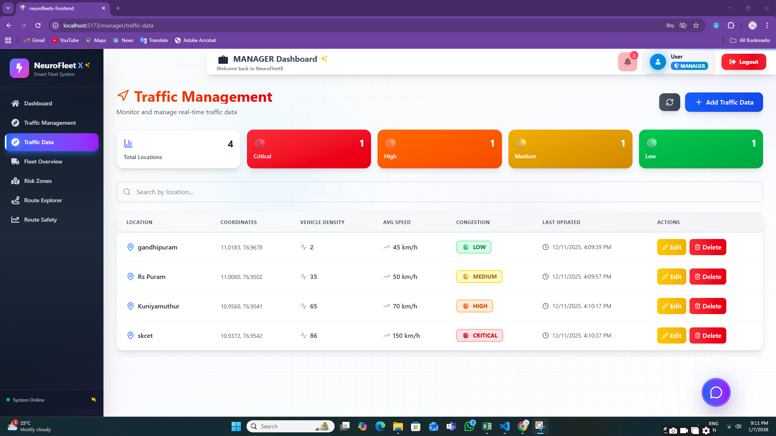

**7.4:Route Explorer**

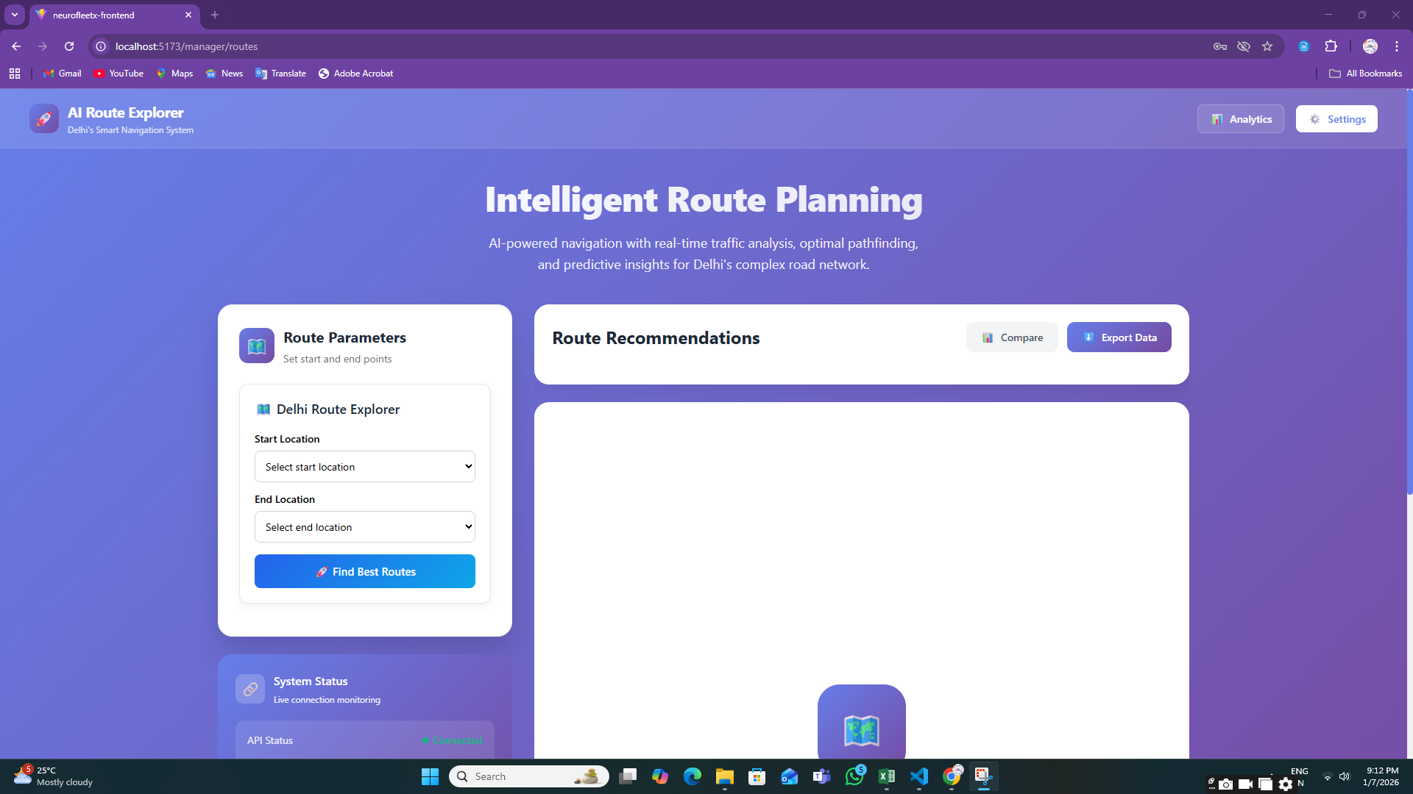

**7.5:Route Safety Analysis**

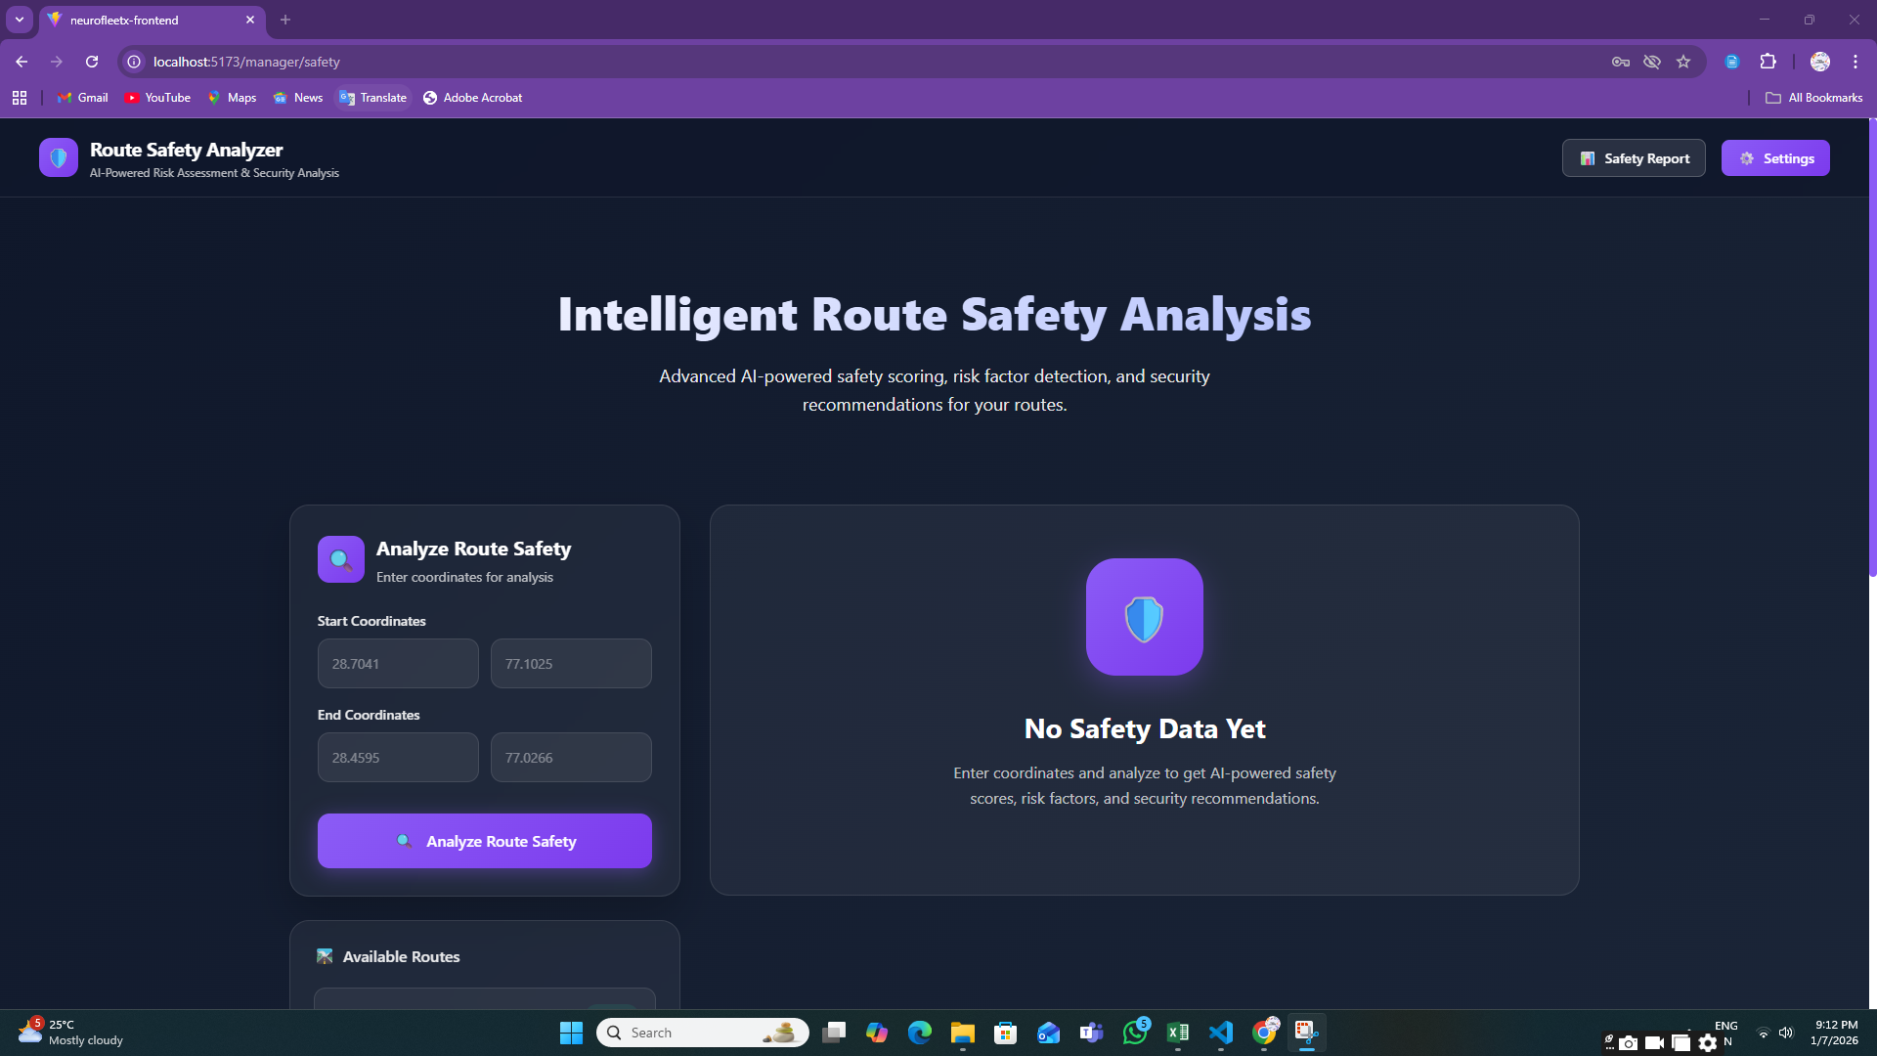

**Step 8:** **DRIVER MODULE**

**8.1:** **Create Trip Page**

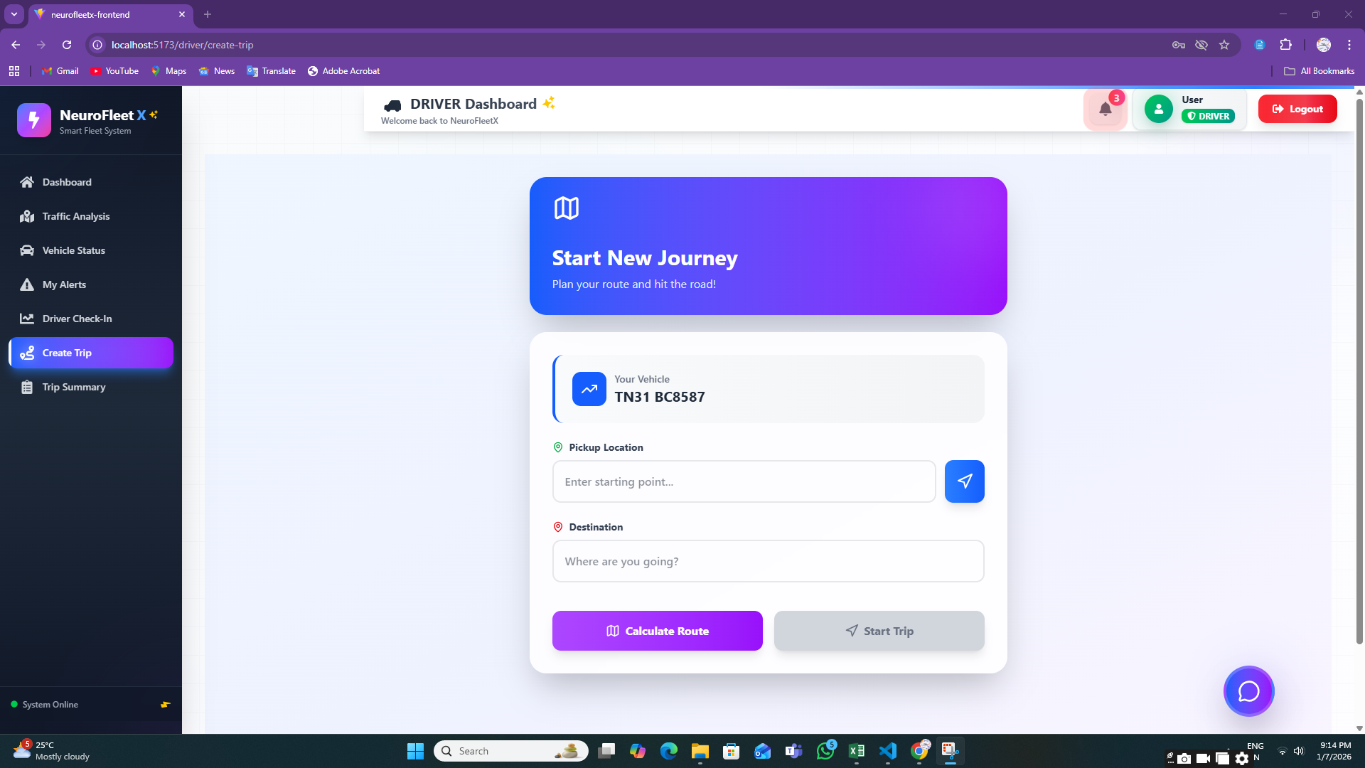

**8.2:** **Route Explorer**

**8.3:** **Traffic Analysis Page**

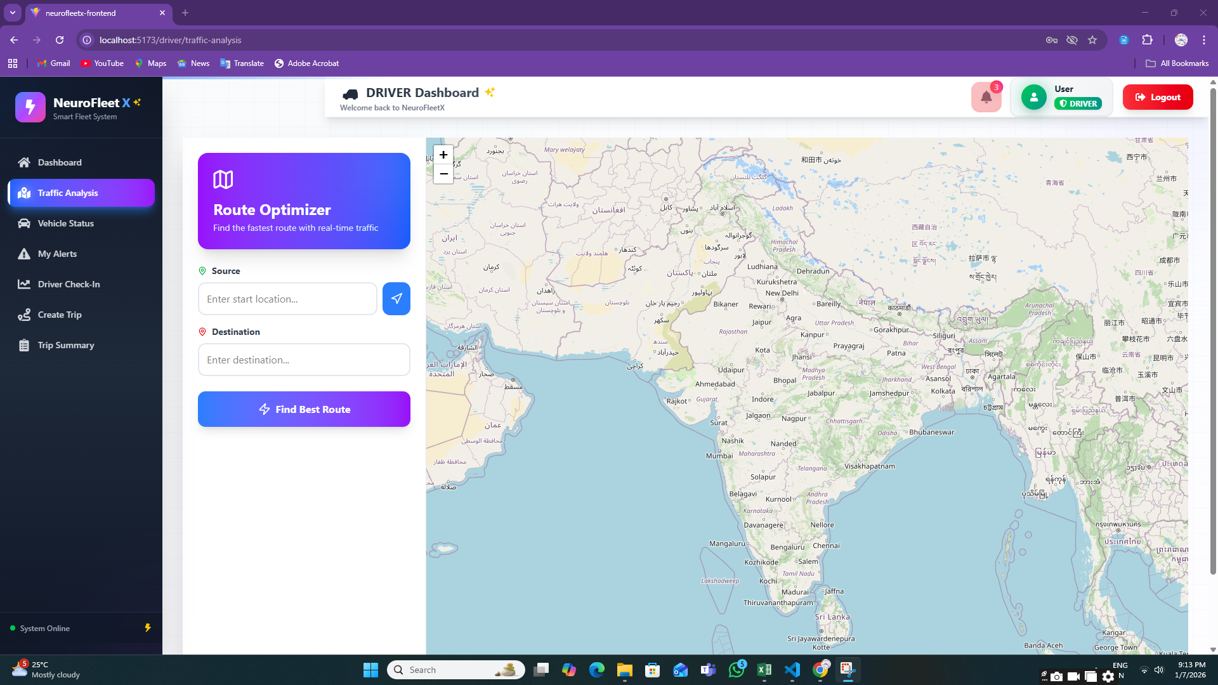

**8.4:** **Vehicle Status Page**

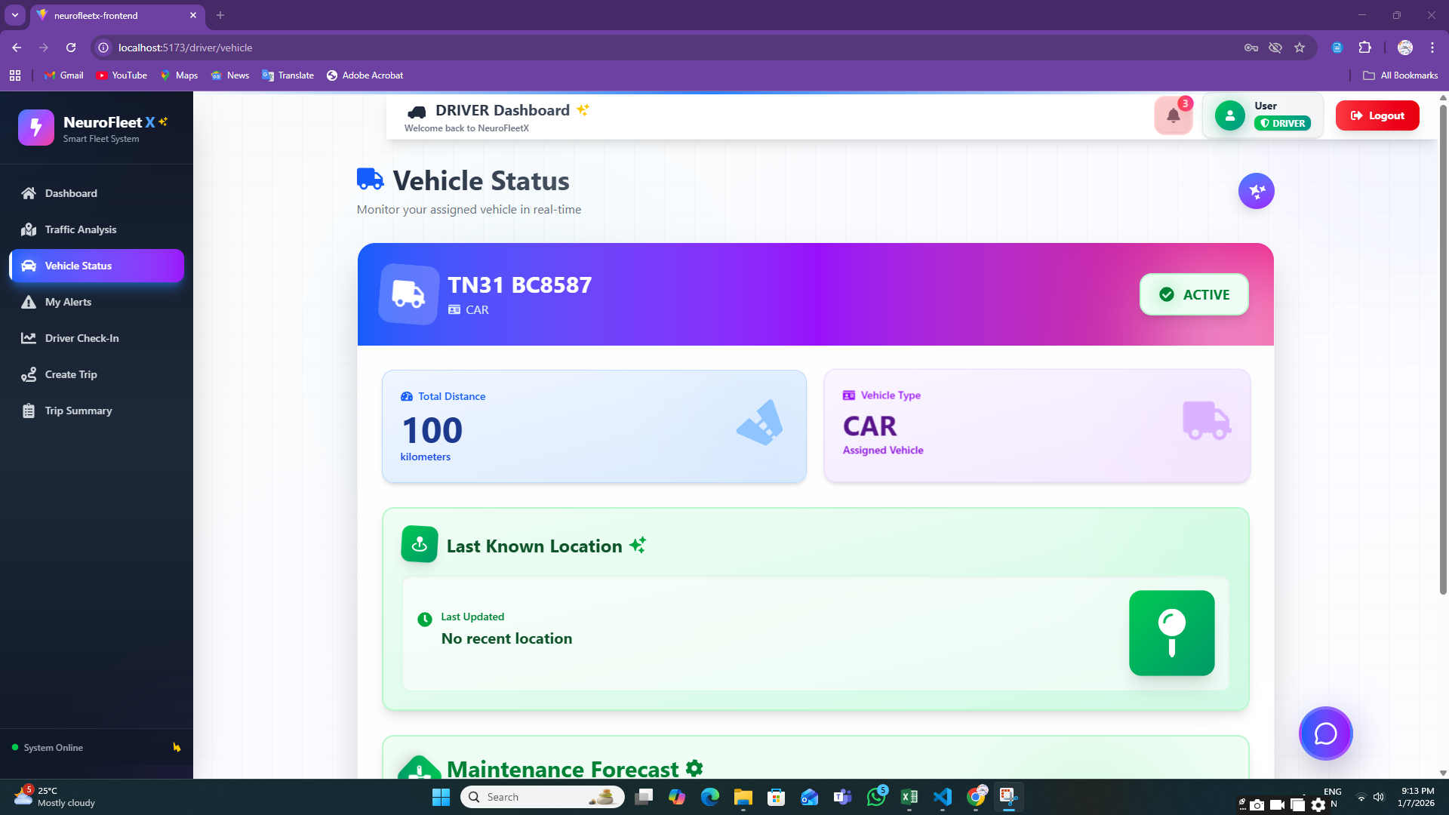

**8.5:** **My Alerts Page**

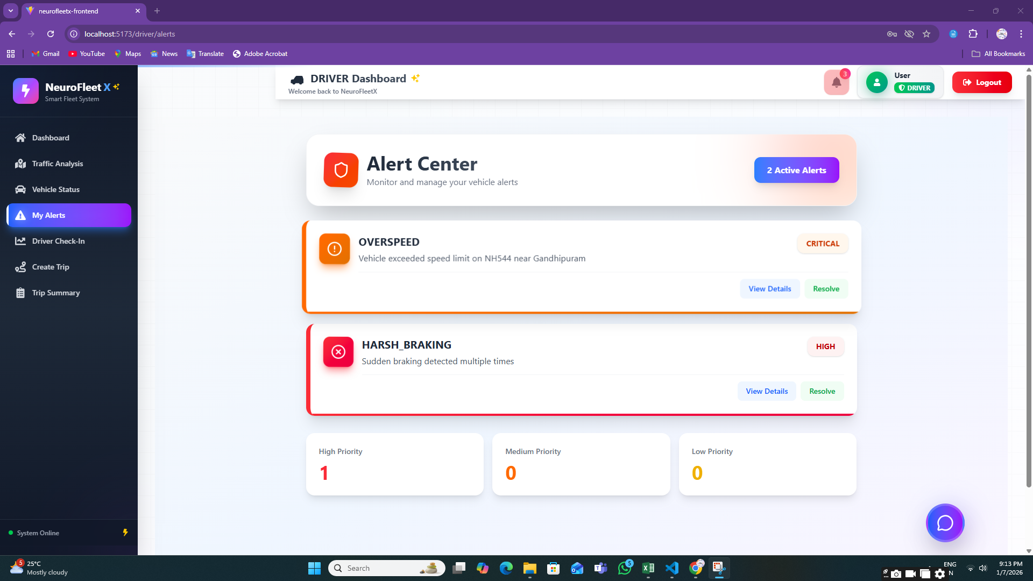

**8.6:** **Driver Check-In**

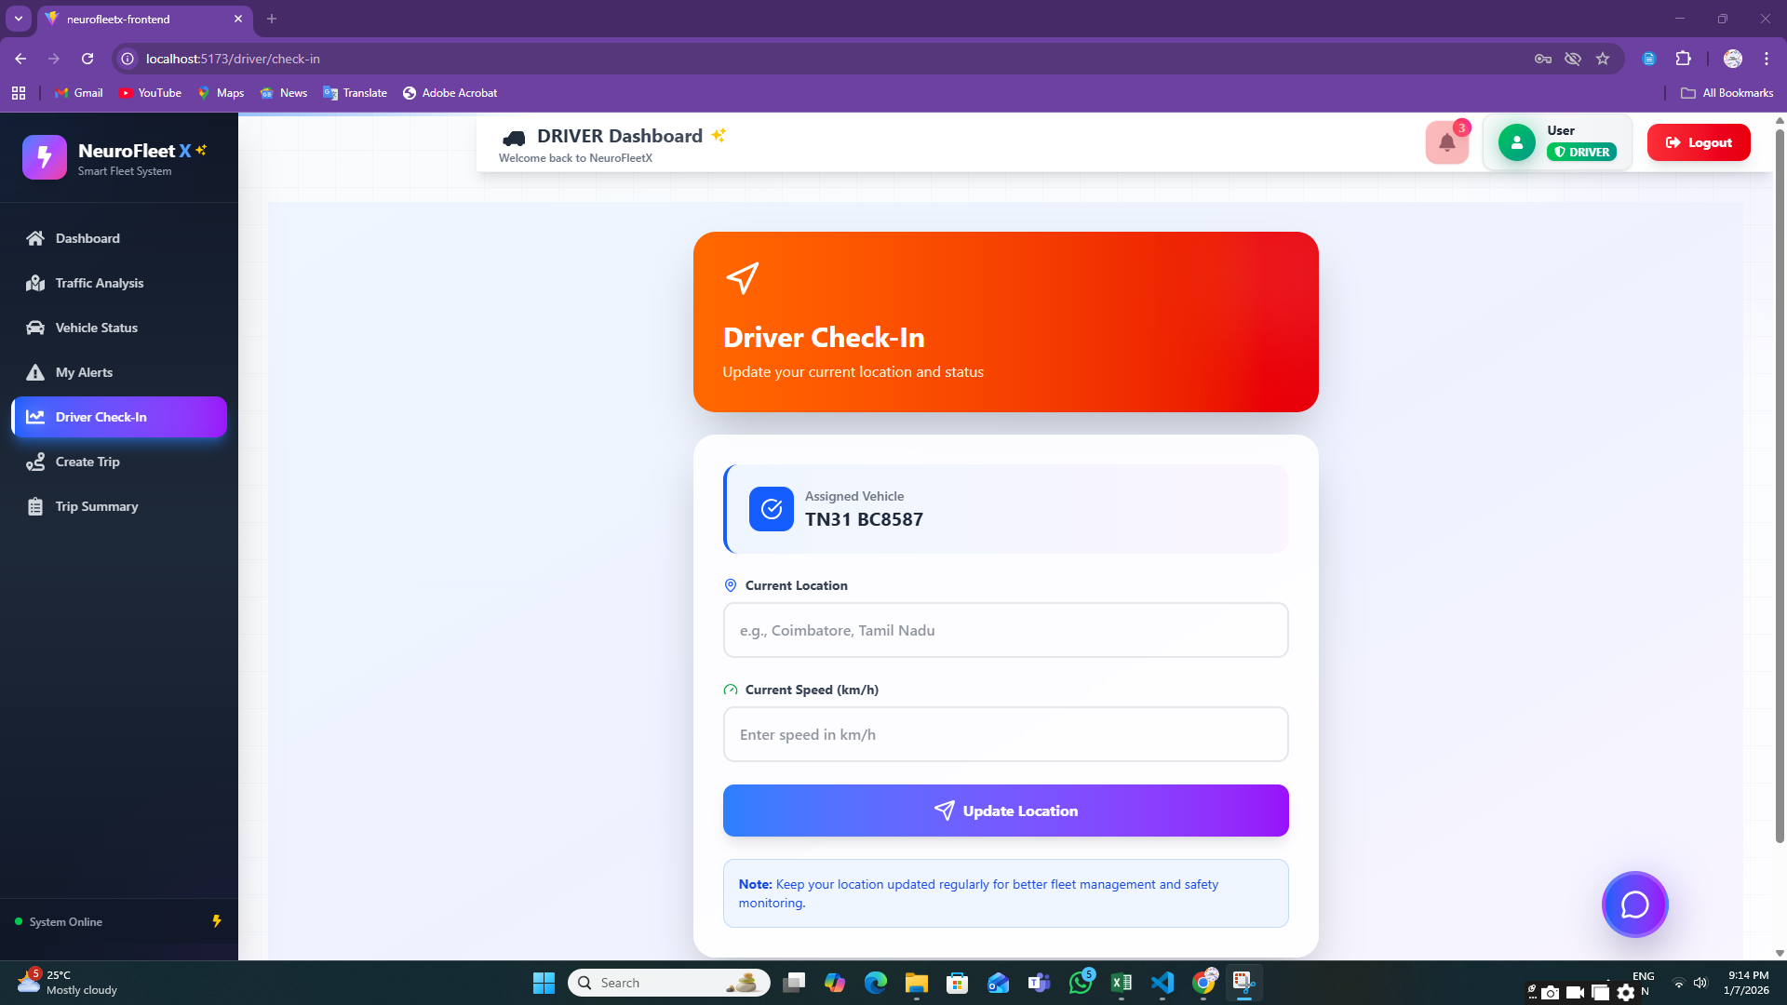

**8.7:** **Trip Summary Page**

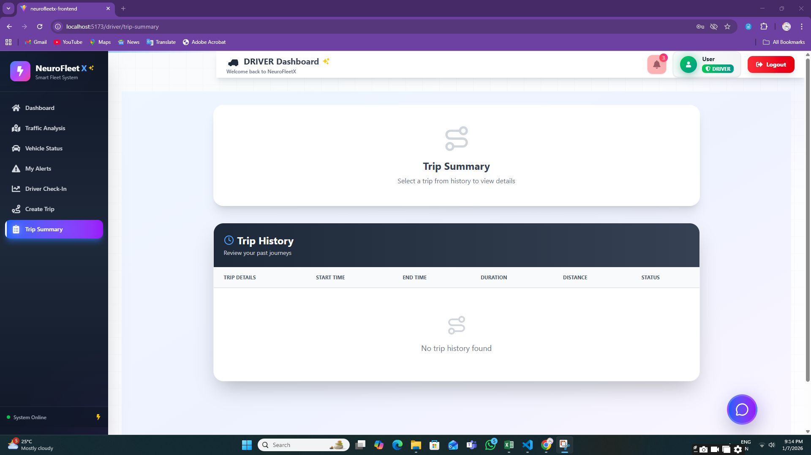

**7. Challenges Faced**

* **Limited Real-Time Traffic Data**Accessing real, live traffic data was difficult, so dummy and manually entered data were used for development and testing.
* **AI & ML Understanding**Understanding AI concepts and deciding how to apply them to traffic prediction and risk analysis was challenging at the beginner level.
* **System Performance Limitations**Laptop performance and memory constraints made AI experimentation and backend processing difficult.
* **AI Integration Complexity**  
  Connecting AI-assisted logic with backend services and frontend dashboards required multiple trials and debugging.
* **Map & Location Handling**Working with maps, coordinates, and location-based data needed careful handling to avoid errors.
* **Role-Based Access Control**  
  Managing different permissions for Admin, Manager, and Driver using JWT required extra attention to security logic.
* **Time Management**  
  Balancing learning, development, debugging, documentation, and presentations within the given timeline was challenging.

# 8. Learnings & Skills Acquired

* **AI Concepts (Basic Level)**  
  Learned how AI can be used for traffic analysis, congestion detection, and route suggestions.
* **Full-Stack Development**  
  Gained hands-on experience in React (frontend), Spring Boot (backend), and MySQL (database).
* **JWT Authentication**  
  Learned how to secure applications using token-based authentication and role-based access.
* **Dashboard & Visualization Skills**  
  Developed dashboards using charts, color indicators, and maps to represent traffic and fleet data.
* **API Development & Integration**  
  Improved skills in building REST APIs and integrating frontend with backend services.
* **Problem Solving & Debugging**  
  Learned to identify errors, debug issues, and improve system stability.
* **Team Collaboration**  
  Improved communication and coordination by working together on shared modules and milestones.

**9. Testimonials from team**

Team Member 1:  
“This project helped me understand how AI concepts can be applied to real-world traffic problems and improved my backend development skills.”

Team Member 2:  
“I learned how to design dashboards and visualize traffic data in a simple and user-friendly way.”

Team Member 3:  
“Working on NeuroFleetX improved my understanding of authentication, role-based access, and system integration.”

Team Member 4:  
“This project gave me confidence to work on full-stack applications and understand how smart city solutions are built.”

**10. Conclusion**

The NeuroFleetX project successfully demonstrates a smart, role-based fleet and traffic management system.  
It provides clear dashboards, alerts, traffic analytics, and AI-assisted features to improve traffic awareness and safety.  
Although advanced AI models are not fully implemented yet, the system is designed in a way that supports future AI and ML integration.  
Overall, the project helped us gain strong technical knowledge, practical experience, and a clear understanding of intelligent transportation systems.

# 11. Acknowledgements

I would like to sincerely thank **our institution and organization** for giving us the opportunity to work on the NeuroFleetX project.  
I am especially grateful to our **mentor** for their continuous guidance, encouragement, and valuable feedback throughout the project.  
I would also like to thank my **team members** for their cooperation, teamwork, and support, which played a major role in successfully completing this project.  
Finally, I thank everyone who directly or indirectly contributed to our learning and project completion.